Declaration:- These are developed using Bootstrap studio as I was lagging but I know the properties and trying to remember and to learn them. These are fully made on blank templates.

***Template Given Link 1:-***

[***https://github.com/rvsp/HTML-CSS/blob/master/Tasks/laud-page.png***](https://github.com/rvsp/HTML-CSS/blob/master/Tasks/laud-page.png)

*index.html*

<!DOCTYPE html>

<html lang="en">

<head>

<meta charset="utf-8">

<meta name="viewport" content="width=device-width, initial-scale=1.0, shrink-to-fit=no">

<title>temp1</title>

<link rel="stylesheet" href="assets/bootstrap/css/bootstrap.min.css">

<link rel="stylesheet" href="assets/css/Article-List.css">

<link rel="stylesheet" href="assets/css/Footer-Dark.css">

<link rel="stylesheet" href="assets/css/styles.css">

<link rel="stylesheet" href="assets/css/Team-Boxed.css">

</head>

<body style="color: rgb(15,16,17);">

<div>

<nav class="navbar navbar-light navbar-expand-md" style="background: #000000;color: rgb(255,255,255);">

<div class="container-fluid">

<div class="collapse navbar-collapse" id="navcol-1" style="color: rgb(252,252,252);">

<ul class="navbar-nav">

<li class="nav-item"><a class="nav-link active" href="#" style="color: rgba(255,255,255,0.9);">Home</a></li>

<li class="nav-item"><a class="nav-link active" href="#" style="color: rgba(255,255,255,0.9);">About</a></li>

<li class="nav-item"><a class="nav-link active" href="#" style="color: rgba(255,255,255,0.9);">Achievements</a></li>

</ul>

</div>

</div>

</nav>

</div>

<div class="container-fluid" style="color: rgb(255,255,255);background: #000000;height: 190px;">

<h1 style="text-align: center;color: rgb(255,255,255);"><br>Kazi Nazrul Islam<br><br></h1>

<p style="text-align: center;color: rgb(255,255,255);">The National Poet of Bangladesh</p>

</div>

<div class="container-fluid">

<div class="row" style="margin: 0px;padding: 25px;">

<div class="col-md-6" style="margin: 0px;">

<div style="border-color: rgb(10,14,18);">

<h2>Rebel Poet</h2>

<p>Kazi Nazrul Islam is the national poet of Bangladesh who is especially recognized as a Bidrohi Kobi (rebel poet) around the country. Nazrul is a famous poet. musician and philosopher of Bangladesh. The famous poet Nazrul's writings deal with the revolution of that period of the British government. His revolutionary attempt helped him to be a national poet of Bangladesh. He has raised his voice against any kinds of fascism and oppression and got popularity swiftly around the Indian Subcontinent. </p>

</div>

<div>

<h2>Awesome Writer</h2>

<p>Nazrul's writings explored themes such as love, freedom, humanity, and revolution. He opposed all forms of bigotry and fundamentalism, including religious, caste-based and gender-based. Throughout his career, Nazrul wrote short stories, novels, and essays but is best known for his songs and poems. He pioneered new music forms such as Bengali ghazals. Nazrul wrote and composed music for nearly 4.000 songs (many recorded on HMV and gramophone records). collectively known as Nazrul Geeti. </p>

</div>

</div>

<div class="col-auto col-md-6 offset-0 text-center align-self-center"><img src="assets/img/bangladesh_national_poet_kazi_nazrul_islam.jpg" style="width: 300px;"></div>

</div>

<div class="text-center"><button class="btn btn-primary" type="button" style="background: rgb(101,110,123);">Learn More</button><button class="btn btn-primary" type="button" style="background: rgb(255,15,0);margin: 10px;">Videos</button><button class="btn btn-primary" type="button" style="background: rgb(218,151,19);">Books</button>

<div class="btn-group" role="group" style="text-align: center;margin: 10px 10px 10px 10px;"></div>

</div>

</div>

<div class="container-fluid" style="color: rgb(244,244,244);background: #000000;height: 70px;">

<p class="text-center" style="padding: 20px;">"Love has no Meaning or Amount" - Kazi Nazrul Islam</p>

</div>

<div class="container-fluid text-start">

<div>

<h2 class="text-center">Awards</h2>

</div>

<div class="row" style="height: 211.4px;">

<div class="col align-self-start" style="height: 200px;border-style: solid;border-radius: 20px;margin: 3px;padding: 8px;">

<h4>Jaggittarani Gold Medal</h4>

<h6>1945</h6>

<p>From the University of Calcutta for his work in Bengali Literature</p>

</div>

<div class="col align-self-start" style="height: 200px;border-style: solid;border-radius: 20px;padding: 8px;margin: 3px;">

<h4>Padma Bhushan</h4>

<h6>1960</h6>

<p style="margin: 0px;">One of the highest civilian honors in Republic of India</p>

</div>

<div class="col align-self-start" style="height: 200px;border-style: solid;border-radius: 20px;padding: 8px;margin: 3px;">

<h4>National Poet</h4>

<h6>-</h6>

<p>Conferred the title by Government of Bangladesh</p>

</div>

<div class="col align-self-start" style="height: 200px;border-style: solid;border-radius: 20px;margin: 3px;padding: 8px;">

<h4>Ekushay Padak</h4>

<h6>1976</h6>

<p>Bangladesh Highest Civilian Honors</p>

</div>

</div>

<div class="row">

<div class="col-md-6">

<h2 class="text-center">Poetry</h2>

<ul>

<li>Agni Bina (The Fiery Lute). 1922 </li>

<li>Sanchita (Collected poems). 1925</li>

<li>Phanimanasa (The Cactus). 1927</li>

<li>Chakrabak (The Flamingo). 1929 </li>

<li>Satbhai Champa (The Seven Brothers of Champa). juvenile poems. 1933</li>

<li>Nirjhar (Fountain). 1939 </li>

<li>Natun Chand (The New Moon). 1939</li>

<li>Morubhaskar (The Sun in the Desert). 1951</li>

<li>Sanchayan (Collected Poems). 1955</li>

<li>Sanchayan (Collected Poems). 1955</li>

</ul>

</div>

<div class="col-md-6">

<h2 class="text-center">Poems &amp; Songs</h2>

<ul>

<li>Dolan Chapa (name of a faintly fragrant monsoon flower), 1923</li>

<li>Bisher Bashi (The Poison Flute). 1924 </li>

<li>Bhangar Gan (The Song of Destruction). 1924 proscribe in 1924</li>

<li>Chhayanat (The Raga of Chhayanat). 1925</li>

<li>Chittanama (On Chittaranjan). 1925</li>

<li>Samyabadi (The Proclaimer of Equality). 1926</li>

<li>Puber Hawa (The Eastern Wind). 1926 </li>

<li>Sarbahara (The Proletariat). 1926 </li>

<li>Sindhu Hindol (The Undulation of the Sea). 1927</li>

<li>Jinjir (Chain). 1928 • Pralaya Shikha (Doomsday Flame). 1930 proscribed in 1930</li>

<li>Shesh Saogat (The Last Offerings). 1958 </li>

</ul>

</div>

</div>

</div>

<footer class="footer-dark" style="background: rgb(0,0,0);">

<div class="container">

<div class="row">

<div class="col-sm-6 col-md-3 item">

<h3>About The Author</h3>

<p>Made By Himal Gautam</p>

</div>

<div class="col-sm-6 col-md-3 item">

<h3>Tech Used</h3>

<p>BootStrap Studio</p>

</div>

<div class="col-md-6 item text">

<h3>Tech Used</h3>

<p><br>Made for the GUVI Task given to Batch 27 Weekend Students for practicing Bootstrap.<br><br></p>

</div>

</div>

</div>

</footer>

<script src="assets/bootstrap/js/bootstrap.min.js"></script>

</body>

</html>

*Article-List.css*

.article-list {

color: #313437;

background-color: #fff;

}

.article-list p {

color: #7d8285;

}

.article-list h2 {

font-weight: bold;

margin-bottom: 40px;

padding-top: 40px;

color: inherit;

}

@media (max-width:767px) {

.article-list h2 {

margin-bottom: 25px;

padding-top: 25px;

font-size: 24px;

}

}

.article-list .intro {

font-size: 16px;

max-width: 500px;

margin: 0 auto;

}

.article-list .intro p {

margin-bottom: 0;

}

.article-list .articles {

padding-bottom: 40px;

}

.article-list .item {

padding-top: 50px;

min-height: 425px;

text-align: center;

}

.article-list .item .name {

font-weight: bold;

font-size: 16px;

margin-top: 20px;

color: inherit;

}

.article-list .item .description {

font-size: 14px;

margin-top: 15px;

margin-bottom: 0;

}

.article-list .item .action {

font-size: 24px;

width: 24px;

margin: 22px auto 0;

line-height: 1;

display: block;

color: #4f86c3;

opacity: 0.85;

transition: opacity 0.2s;

text-decoration: none;

}

.article-list .item .action:hover {

opacity: 1;

}

*Footer-Dark.css*

.footer-dark {

padding: 50px 0;

color: #f0f9ff;

background-color: #282d32;

}

.footer-dark h3 {

margin-top: 0;

margin-bottom: 12px;

font-weight: bold;

font-size: 16px;

}

.footer-dark ul {

padding: 0;

list-style: none;

line-height: 1.6;

font-size: 14px;

margin-bottom: 0;

}

.footer-dark ul a {

color: inherit;

text-decoration: none;

opacity: 0.6;

}

.footer-dark ul a:hover {

opacity: 0.8;

}

@media (max-width:767px) {

.footer-dark .item:not(.social) {

text-align: center;

padding-bottom: 20px;

}

}

.footer-dark .item.text {

margin-bottom: 36px;

}

@media (max-width:767px) {

.footer-dark .item.text {

margin-bottom: 0;

}

}

.footer-dark .item.text p {

opacity: 0.6;

margin-bottom: 0;

}

.footer-dark .item.social {

text-align: center;

}

@media (max-width:991px) {

.footer-dark .item.social {

text-align: center;

margin-top: 20px;

}

}

.footer-dark .item.social > a {

font-size: 20px;

width: 36px;

height: 36px;

line-height: 36px;

display: inline-block;

text-align: center;

border-radius: 50%;

box-shadow: 0 0 0 1px rgba(255,255,255,0.4);

margin: 0 8px;

color: #fff;

opacity: 0.75;

}

.footer-dark .item.social > a:hover {

opacity: 0.9;

}

.footer-dark .copyright {

text-align: center;

padding-top: 24px;

opacity: 0.3;

font-size: 13px;

margin-bottom: 0;

}

*Styles.css*

nav {

}

*Team-Boxed.css*

.team-boxed {

color: #313437;

background-color: #eef4f7;

}

.team-boxed p {

color: #7d8285;

}

.team-boxed h2 {

font-weight: bold;

margin-bottom: 40px;

padding-top: 40px;

color: inherit;

}

@media (max-width:767px) {

.team-boxed h2 {

margin-bottom: 25px;

padding-top: 25px;

font-size: 24px;

}

}

.team-boxed .intro {

font-size: 16px;

max-width: 500px;

margin: 0 auto;

}

.team-boxed .intro p {

margin-bottom: 0;

}

.team-boxed .people {

padding: 50px 0;

}

.team-boxed .item {

text-align: center;

}

.team-boxed .item .box {

text-align: center;

padding: 30px;

background-color: #fff;

margin-bottom: 30px;

}

.team-boxed .item .name {

font-weight: bold;

margin-top: 28px;

margin-bottom: 8px;

color: inherit;

}

.team-boxed .item .title {

text-transform: uppercase;

font-weight: bold;

color: #d0d0d0;

letter-spacing: 2px;

font-size: 13px;

}

.team-boxed .item .description {

font-size: 15px;

margin-top: 15px;

margin-bottom: 20px;

}

.team-boxed .item img {

max-width: 160px;

}

.team-boxed .social {

font-size: 18px;

color: #a2a8ae;

}

.team-boxed .social a {

color: inherit;

margin: 0 10px;

display: inline-block;

opacity: 0.7;

}

.team-boxed .social a:hover {

opacity: 1;

}

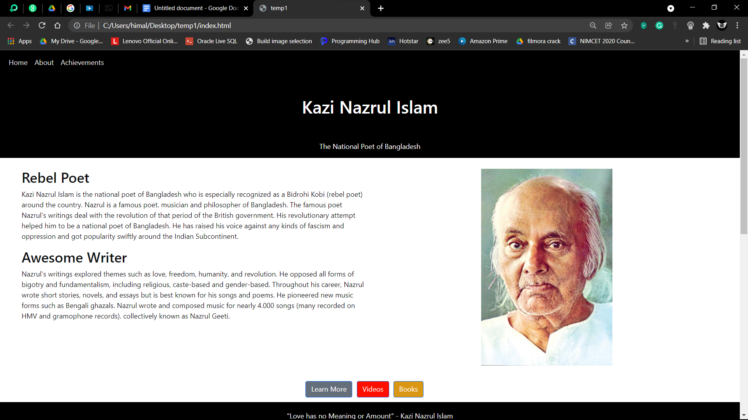

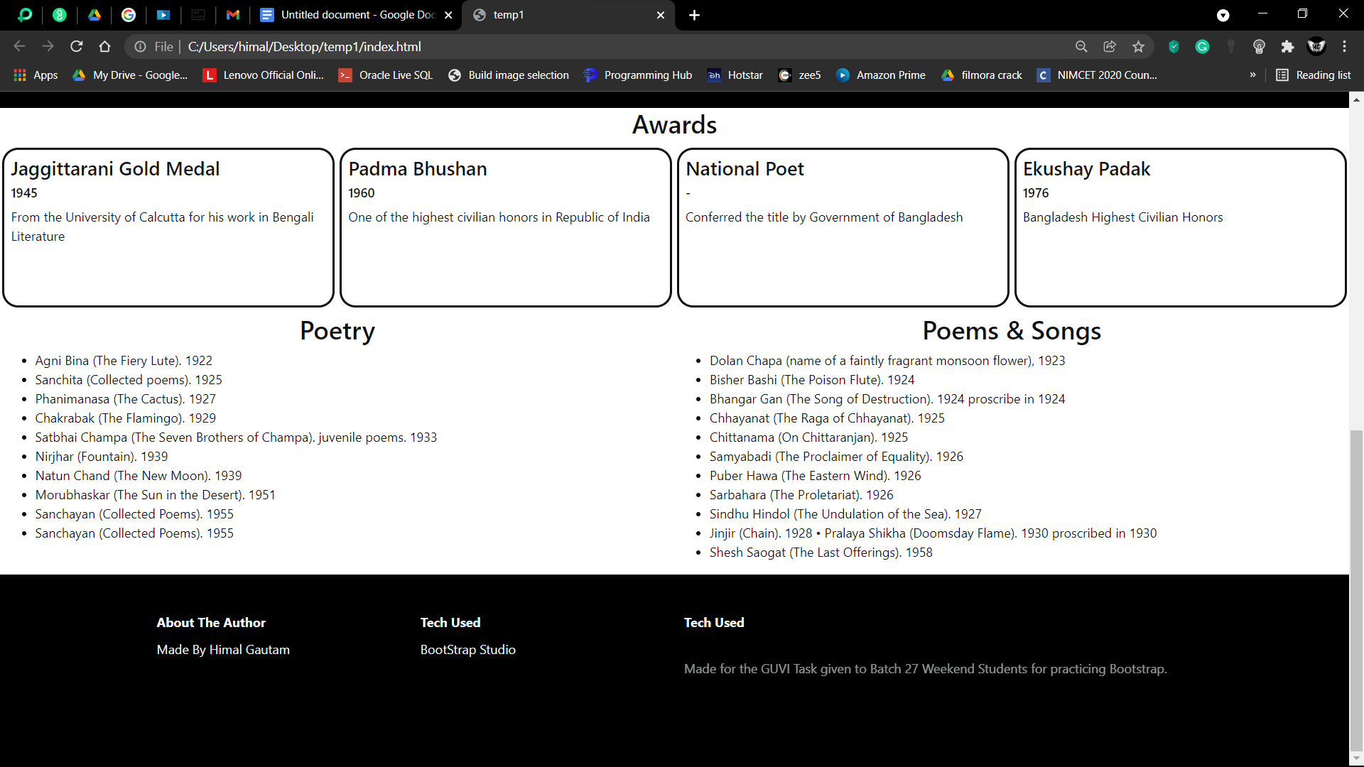

Containers are flex so we can adjust screen sizes…………

***Template Given Link 2:-***

[***https://github.com/rvsp/HTML-CSS/blob/master/Tasks/task-banner-2.jpeg***](https://github.com/rvsp/HTML-CSS/blob/master/Tasks/task-banner-2.jpeg)

*index.html*

<!DOCTYPE html>

<html lang="en" style="margin: 100px;">

<head>

<meta charset="utf-8">

<meta name="viewport" content="width=device-width, initial-scale=1.0, shrink-to-fit=no">

<title>temp2</title>

<link rel="stylesheet" href="assets/bootstrap/css/bootstrap.min.css">

<link rel="stylesheet" href="assets/css/styles.css">

</head>

<body class="text-center" style="background: rgb(78,74,74);">

<div class="align-self-center" style="width: 701.6px;margin: auto;padding: 1 rem;">

<div>

<div class="container text-center float-start">

<h1 style="color: var(--bs-red);font-weight: bold;">OBESITY</h1>

<h5 class="text-center" style="color: rgb(195,195,195);">CHILDHOOD STATISTICS</h5>

</div>

</div>

<div class="container-fluid" style="margin: 15px;">

<div class="row">

<div class="col-md-6" style="background: #ff8a00;">

<h1>1 IN 3</h1>

<p>children andadolescents (age 2 -19)</p>

<h1>ARE OVERWEIGHT OR OBESE</h1>

<p>and almost none meet recommended healthy diet and physical activity amount.</p>

</div>

<div class="col-md-6" style="background: #00b2ff;">

<p>an estimated</p>

<h1>12.5 BILLION</h1>

<p>children (ages 5 years or younger), spend</p>

<h1>33 HOURS / WEEK</h1>

<p>in child care setting and consume nearly all of their daily calories.</p>

</div>

</div>

</div>

<div class="container-fluid" style="margin: 15px;background: #fb0000;">

<div class="col">

<h1>OBESITY IS LINKED TO MORE CHRONIC CONDITIONS THAN: </h1>

<p>increasing the risk of more than 20 preventable diseases including sleep apnea, asthma, heart disease. type 2 diabetes, osteoarthnlis, high blood pressure and high.cholesterol stroke.</p>

</div>

</div>

<div class="container-fluid" style="margin: 15px;background: #00b2ff;">

<div class="col">

<h1>RISK FACTORS</h1>

<div class="float-start" style="width: 50%;">

<p>Children in their early teens are obese and who have high triglycerlde lath have arteries similar to those of 45-year olds </p>

<p class="float-none">Obese children as young as age 3 show indicators for developing heart disease later in life.&nbsp;<br></p>

</div>

<div class="float-start" style="width: 50%;">

<p>Children who are overweight from the ages of 7 to 13 may develop hurt disease as early as age 25&nbsp;<br></p>

<p class="float-none">Obese children are twice as likely to die before age 55 than their slimmer peers.&nbsp;<br></p>

</div>

<div>

<p>&nbsp; &nbsp;</p>

</div>

</div>

</div>

<div class="container-fluid" style="margin: 15px;">

<div class="row">

<div class="col-md-6 text-center" style="background: #ff1414;">

<h1>French Fries</h1>

<p>are the most common vegetable that childre eat, comprising</p>

<h1>25 %</h1>

<p>of their vegetable intake</p>

<p></p>

</div>

<div class="col-md-6 text-center" style="background: #ffab09;">

<h1>JUICE</h1>

<p>(which may lack important fibers found in whole fruits) makes up</p>

<h1>40 %</h1>

<p>of Children's daily fruit intake</p>

</div>

</div>

</div>

<div class="container-fluid" style="margin: 15px;background: #13dbf7;">

<div class="col">

<h1>40% - 50% OF</h1>

<h1>TODDLERS</h1>

<p>watch more television than recommended</p>

</div>

</div>

<div class="container-fluid" style="margin: 15px;background: #ffab09;">

<div class="col" style="background: #ffab09;">

<h1>NEARLY 1/2 OF</h1>

<h1>PRESCHOOLERS</h1>

<p>Don't get enough physical acctivity.</p>

</div>

</div>

<div class="container-fluid" style="margin: 15px;background: #7e3838;">

<div class="row">

<div class="col-md-6" style="background: #00f0ff;">

<p class="text-center" style="transform: scale(1);">The Cost of obesity in the United States is staggering total about</p>

<h1 class="text-center">$147 BILLION</h1>

</div>

<div class="col-md-6 text-center" style="background: #fb1c1c;">

<h4>CHILDREN WHO EAT HEALTHY FOOD AND GET DAILY PHYSICL ACTIVITY HAVE:</h4>

<p></p>

<ul class="list-unstyled">

<li>Fewer School Absences</li>

<li>Higher Academic Achievements</li>

<li>Higher Self-Esteem</li>

<li>Fewer behavorial problems</li>

</ul>

</div>

</div>

</div>

</div>

<script src="assets/bootstrap/js/bootstrap.min.js"></script>

</body>

</html>

*styles.css*

* {

padding: 0.2rem;

}

